PROJECT FINAL REPORT
“Telecommunication Company”
System & Network Security

Table of Contents

S no. | CONTENTS | Pg no.
1 | Problem Statement | 1
2 | Implemented Solution | 2
3 | Theory Discussion | 3
4 | Software Tool(s) | 4
5 | Steps of Working | 5
6 | Topology | 6
7 | Limitations | 7
8 | Final Results | 8
9 | Applications | 9
10 | References | 10

PROBLEM STATEMENT
The telecommunication company is facing major challenges with its existing network infrastructure, which is outdated, unoptimized, and lacks essential security controls. The flat network design creates performance bottlenecks, large broadcast domains, and exposes the system to cyber-attacks. The absence of proper segmentation, centralized management, wireless control, and secure voice communication makes it difficult for the company to meet modern operational and scalability requirements. Without a redesigned, future-ready network, the organization risks inefficiency, compromised security, and service interruptions, which can negatively affect its performance and customer trust.

IMPLEMENTED SOLUTION
To address these issues, a scalable, secure, and modernized network infrastructure was developed using Cisco Packet Tracer. The solution follows a two-tier hierarchical design that separates the network into structured layers and introduces VLAN-based segmentation for data, Wi-Fi, and voice services. Layer 3 switching and OSPF routing were implemented to ensure smooth inter-VLAN communication. A fully configured Wireless LAN Controller manages enterprise Wi-Fi, while a Cisco Voice Gateway running Call Manager Express handles VoIP communication. Centralized DHCP services operate through the AD server for wired/wireless devices and through the voice gateway for phones. A firewall with NAT, ACLs, and traffic inspection secures the network perimeter. The implemented solution ensures improved performance, scalability, and enhanced network security while supporting all enterprise services effectively.

THEORY DISCUSSION
Modern network design relies heavily on hierarchical architecture and segmentation principles to improve efficiency and security. VLANs are employed to divide the network into smaller, isolated domains, reducing unnecessary broadcasting and improving performance. Layer 3 inter-VLAN routing enables communication between these segments, while OSPF, a dynamic routing protocol, ensures reliable path selection and scalability across the network. DHCP automates IP assignment, minimizing manual configuration errors. Wireless infrastructure is centrally managed through a Wireless LAN Controller, ensuring better security policies, roaming, and monitoring. Voice over IP technology provides cost-effective communication by converting voice signals into data packets. Firewall implementation remains critical for traffic inspection, threat prevention, NAT translation, and zone-based security. Each of these components contributes to a secure, efficient, and manageable enterprise network.

SOFTWARE TOOL

- Cisco Packet Tracer [2]

STEPS OF WORKING
• Designed the network topology with routers, switches, firewall, servers, WLC, and end devices.
• Performed basic device configuration including IP setup, hostnames, and secure remote access.
• Created VLANs for wired users, wireless users, and voice networks.
• Assigned switch ports to VLANs and enabled PortFast and BPDU Guard.
• Configured Layer 3 routing using SVIs and enabled OSPF for dynamic routing.
• Set up DHCP for data and voice devices using AD Server and Voice Gateway.
• Configured VoIP features on CME and registered IP phones.
• Deployed enterprise Wi-Fi using the WLC with SSID and security configuration.
• Configured firewall NAT, ACLs, and security zones for traffic protection.
• Tested connectivity, VoIP calls, Wi-Fi, routing, and firewall rules.

TOPOLOGY

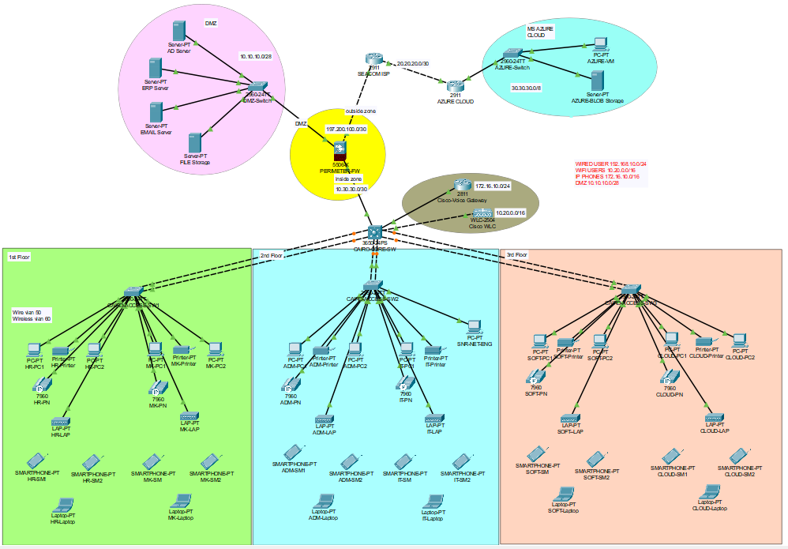
Fig. No. 1 “Topology of Network” [1]

LIMITATIONS:
Although the design is functional and meets enterprise requirements, some limitations exist due to simulation constraints. Cisco Packet Tracer does not fully support advanced firewall features, real-world wireless radio behaviors, or enterprise-grade redundancy techniques. Performance testing, high availability, and stress simulations cannot be accurately replicated. Additionally, some VoIP and WLC functionalities are simplified compared to real hardware. Despite these constraints, the simulation effectively represents a realistic enterprise network environment.

FINAL RESULT:
The final implemented network successfully delivered a secure, scalable, and fully operational enterprise infrastructure. All network services—including inter-VLAN routing, DHCP automation, NAT, firewall security, wireless connectivity, and VoIP communications—worked seamlessly. IP phones registered successfully, wireless clients authenticated through the WLC, and data devices communicated across VLANs via OSPF. Security measures such as ACLs, BPDU Guard, PortFast, and NAT effectively enhanced protection. The result is a modernized and well-structured network ready for deployment in a real organizational environment.

APPLICATIONS
• Telecommunication headquarters and branch networks
• University and hospital campus networks
• Medium-scale enterprise environments
• Corporate buildings needing Wi-Fi, VoIP, and centralized management
• Training labs for network engineers
• A secure testbed for evaluating future policies or configurations

REFERENCES
[1] Building the topology, “Idea”, 2024. [Online], Available:
https://youtu.be/w3DfcqZ8xOI?si=w8begQMw16V1zObK [Accessed: 13-November-2025].
[2] Cisco-packet-tracer, “Software”, 2024. [Online], Available:
https://www.netacad.com/cisco-packet-tracer [Accessed: 13-November-2025].
[3] Routing Protocols and their Security in Cisco. [Online], Available:
https://www.cisco.com/[Accessed: 13-November-2025]

